**INTCDE21ID008**

**STAGE-3**

**916398 – SAAHIL TOMAR**

**Day 5 –** ASP .Net core

**Hands-On:**

1. Create a Razor view to list a few Organizations at Hyderabad and highlight the one that has recently built its largest offshore office at India.

**HomeController.cs**

using Microsoft.AspNetCore.Mvc;

using Microsoft.Extensions.Logging;

using OrganizationsAtHyderabad.Models;

using System;

using System.Collections.Generic;

using System.Diagnostics;

using System.Linq;

using System.Threading.Tasks;

namespace OrganizationsAtHyderabad.Controllers

{

public class HomeController : Controller

{

private readonly ILogger<HomeController> _logger;

public HomeController(ILogger<HomeController> logger)

{

_logger = logger;

}

public IActionResult Index()

{

return View();

}

public IActionResult Privacy()

{

return View();

}

public IActionResult ITOrganizations()

{

List<string> organizationList = new List<string>

{

"Microsoft www.microsoft.com","CTS www.cognizant.com", "Google", "Amazon","TCS"

};

return View(organizationList);

}

[ResponseCache(Duration = 0, Location = ResponseCacheLocation.None, NoStore = true)]

public IActionResult Error()

{

return View(new ErrorViewModel { RequestId = Activity.Current?.Id ?? HttpContext.TraceIdentifier });

}

}

}

**ITOrganisations.cshtml**

@*

For more information on enabling MVC for empty projects, visit https://go.microsoft.com/fwlink/?LinkID=397860

*@

@{

}

@model List<string>

@foreach (var organization in Model)

{

< div >

@if(organization.Equals("Amazon"))

{

< span >< b > @Html.DisplayFor(o => organization) </ b ></ span >

}

else

{

< span > @Html.DisplayFor(o => organization) </ span >

}

</ div >

}

**_Layout.cs**

< !DOCTYPE html >

< html lang = "en" >

< head >

< meta charset = "utf-8" />

< meta name = "viewport" content = "width=device-width, initial-scale=1.0" />

< title > @ViewData["Title"] - OrganizationsAtHyderabad </ title >

< link rel = "stylesheet" href = "~/lib/bootstrap/dist/css/bootstrap.min.css" />

< link rel = "stylesheet" href = "~/css/site.css" />

</ head >

< body >

< header >

< nav class= "navbar navbar-expand-sm navbar-toggleable-sm navbar-light bg-white border-bottom box-shadow mb-3" >

< div class= "container" >

< a class= "navbar-brand" asp - area = "" asp - controller = "Home" asp - action = "Index" > OrganizationsAtHyderabad </ a >

< button class= "navbar-toggler" type = "button" data - toggle = "collapse" data - target = ".navbar-collapse" aria - controls = "navbarSupportedContent"

aria - expanded = "false" aria - label = "Toggle navigation" >

< span class= "navbar-toggler-icon" ></ span >

</ button >

< div class= "navbar-collapse collapse d-sm-inline-flex flex-sm-row-reverse" >

< ul class= "navbar-nav flex-grow-1" >

< li class= "nav-item" >

< a class= "nav-link text-dark" asp - area = "" asp - controller = "Home" asp - action = "Index" > Home </ a >

</ li >

< li class= "nav-item" >

< a class= "nav-link text-dark" asp - area = "" asp - controller = "Home" asp - action = "Privacy" > Privacy </ a >

</ li >

< li class= "nav-item" >

< a class= "nav-link text-dark" asp - area = "" asp - controller = "Home" asp - action = "ITOrganizations" > ITOrganizations </ a >

</ li >

</ ul >

</ div >

</ div >

</ nav >

</ header >

< div class= "container" >

< main role = "main" class= "pb-3" >

@RenderBody()

</ main >

</ div >

< footer class= "border-top footer text-muted" >

< div class= "container" >

&copy; 2021 - OrganizationsAtHyderabad - < a asp - area = "" asp - controller = "Home" asp - action = "Privacy" > Privacy </ a >

</ div >

</ footer >

< script src = "~/lib/jquery/dist/jquery.min.js" ></ script >

< script src = "~/lib/bootstrap/dist/js/bootstrap.bundle.min.js" ></ script >

< script src = "~/js/site.js" asp - append - version = "true" ></ script >

@RenderSection("Scripts", required: false)

</ body >

</ html >

**OUTPUT:**

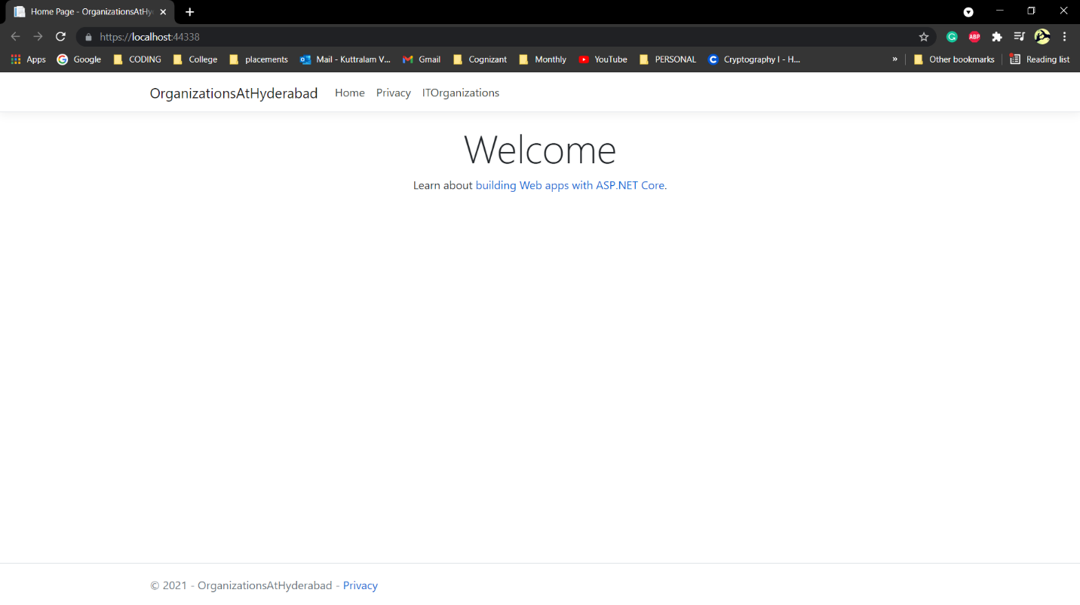



1. Create a Razor view to list few employee details using Model data binding.

**Employee.cs**

using System;

using System.Collections.Generic;

using System.Linq;

using System.Threading.Tasks;

namespace EmployeeDetails.Models

{

public class Employee

{

public int Id { get; set; }

public string Name { get; set; }

public decimal Salary { get; set; }

public bool IsPermanent { get; set; }

}

}

**HomeController.cs**

using EmployeeDetails.Models;

using Microsoft.AspNetCore.Mvc;

using Microsoft.Extensions.Logging;

using System;

using System.Collections.Generic;

using System.Diagnostics;

using System.Linq;

using System.Threading.Tasks;

namespace EmployeeDetails.Controllers

{

public class HomeController : Controller

{

private readonly ILogger<HomeController> _logger;

public HomeController(ILogger<HomeController> logger)

{

_logger = logger;

}

public IActionResult Index()

{

return View();

}

public IActionResult Privacy()

{

return View();

}

public IActionResult GetEmployeeList()

{

List<Employee> employeeList = new List<Employee>();

employeeList.Add(new Employee()

{

Id = 1,

Name = "John",

Salary = 10000,

IsPermanent = true

});

employeeList.Add(new Employee()

{

Id = 2,

Name = "Smith",

Salary = 5000,

IsPermanent = false

});

employeeList.Add(new Employee()

{

Id = 3,

Name = "Mark",

Salary = 5000,

IsPermanent = false

});

employeeList.Add(new Employee()

{

Id = 4,

Name = "Mary",

Salary = 5000,

IsPermanent = false

});

return View(employeeList);

}

[ResponseCache(Duration = 0, Location = ResponseCacheLocation.None, NoStore = true)]

public IActionResult Error()

{

return View(new ErrorViewModel { RequestId = Activity.Current?.Id ?? HttpContext.TraceIdentifier });

}

}

}

**GetEmployeeList.cshtml**

@*

For more information on enabling MVC for empty projects, visit https://go.microsoft.com/fwlink/?LinkID=397860

*@

@model List<EmployeeDetails.Models.Employee>

@{

ViewData["Title"] = "GetEmployeeList";

< div class= "row" >

< span class= "col-md-4" > Name </ span >

< span class= "col-md-4" > Salary </ span >

< span class= "col-md-4" > IsPermanent </ span >

</ div >

}

@foreach(var employee in Model)

{

< div class= "row" >

@if(employee.IsPermanent.Equals(true))

{

< span class= "col-md-4" >< b > @employee.Name </ b ></ span >

< span class= "col-md-4" >< b > @employee.Salary </ b ></ span >

< span class= "col-md-4" >< b > @employee.IsPermanent </ b ></ span >

}

else

{

< span class= "col-md-4" > @employee.Name </ span >

< span class= "col-md-4" > @employee.Salary </ span >

< span class= "col-md-4" > @employee.IsPermanent </ span >

}

</ div >

}

**_Layout.cshtml**

<!DOCTYPE html>

< html lang = "en" >

< head >

< meta charset = "utf-8" />

< meta name = "viewport" content = "width=device-width, initial-scale=1.0" />

< title > @ViewData["Title"] - EmployeeDetails </ title >

< link rel = "stylesheet" href = "~/lib/bootstrap/dist/css/bootstrap.min.css" />

< link rel = "stylesheet" href = "~/css/site.css" />

</ head >

< body >

< header >

< nav class= "navbar navbar-expand-sm navbar-toggleable-sm navbar-light bg-white border-bottom box-shadow mb-3" >

< div class= "container" >

< a class= "navbar-brand" asp - area = "" asp - controller = "Home" asp - action = "Index" > EmployeeDetails </ a >

< button class= "navbar-toggler" type = "button" data - toggle = "collapse" data - target = ".navbar-collapse" aria - controls = "navbarSupportedContent"

aria - expanded = "false" aria - label = "Toggle navigation" >

< span class= "navbar-toggler-icon" ></ span >

</ button >

< div class= "navbar-collapse collapse d-sm-inline-flex flex-sm-row-reverse" >

< ul class= "navbar-nav flex-grow-1" >

< li class= "nav-item" >

< a class= "nav-link text-dark" asp - area = "" asp - controller = "Home" asp - action = "Index" > Home </ a >

</ li >

< li class= "nav-item" >

< a class= "nav-link text-dark" asp - area = "" asp - controller = "Home" asp - action = "Privacy" > Privacy </ a >

</ li >

< li class= "nav-item" >

< a class= "nav-link text-dark" asp - area = "" asp - controller = "Home" asp - action = "GetEmployeeList" > GetEmployeeList </ a >

</ li >

</ ul >

</ div >

</ div >

</ nav >

</ header >

< div class= "container" >

< main role = "main" class= "pb-3" >

@RenderBody()

</ main >

</ div >

< footer class= "border-top footer text-muted" >

< div class= "container" >

&copy; 2021 - EmployeeDetails - < a asp - area = "" asp - controller = "Home" asp - action = "Privacy" > Privacy </ a >

</ div >

</ footer >

< script src = "~/lib/jquery/dist/jquery.min.js" ></ script >

< script src = "~/lib/bootstrap/dist/js/bootstrap.bundle.min.js" ></ script >

< script src = "~/js/site.js" asp - append - version = "true" ></ script >

@RenderSection("Scripts", required: false)

</ body >

</ html >

**OUTPUT:**

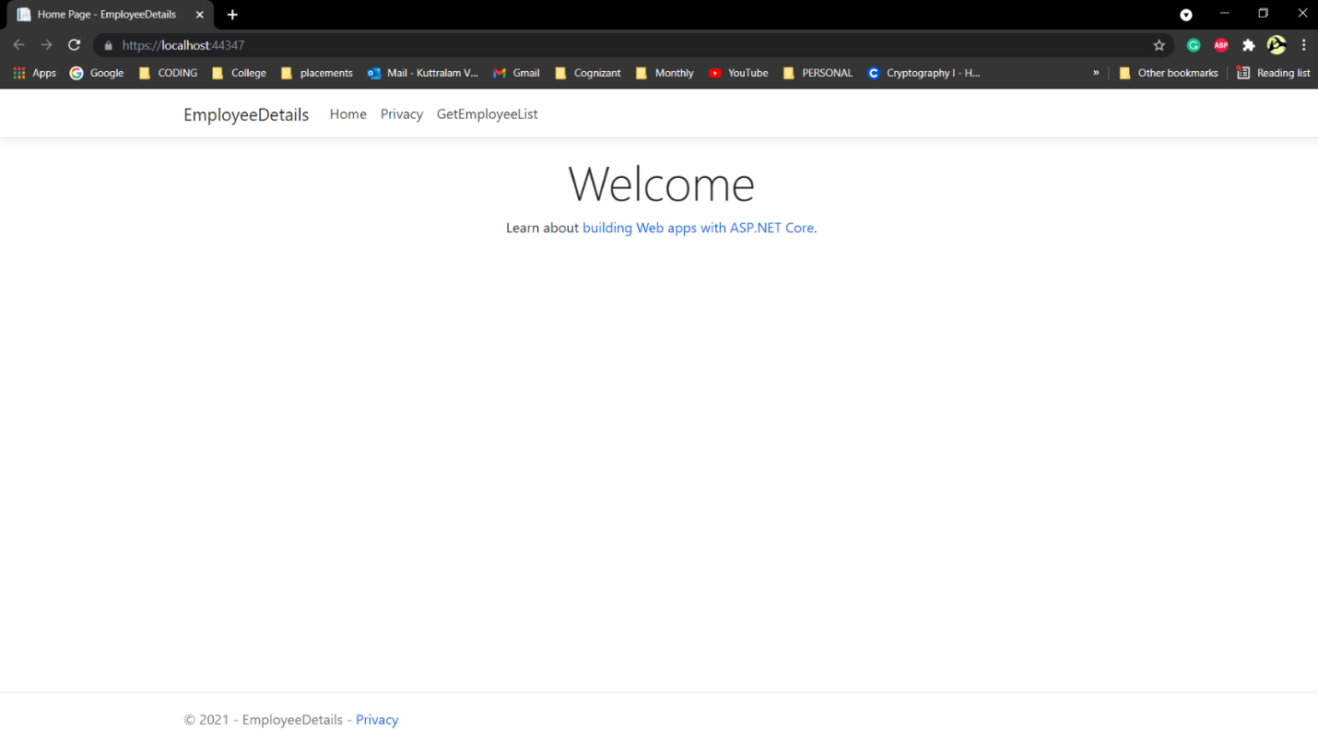

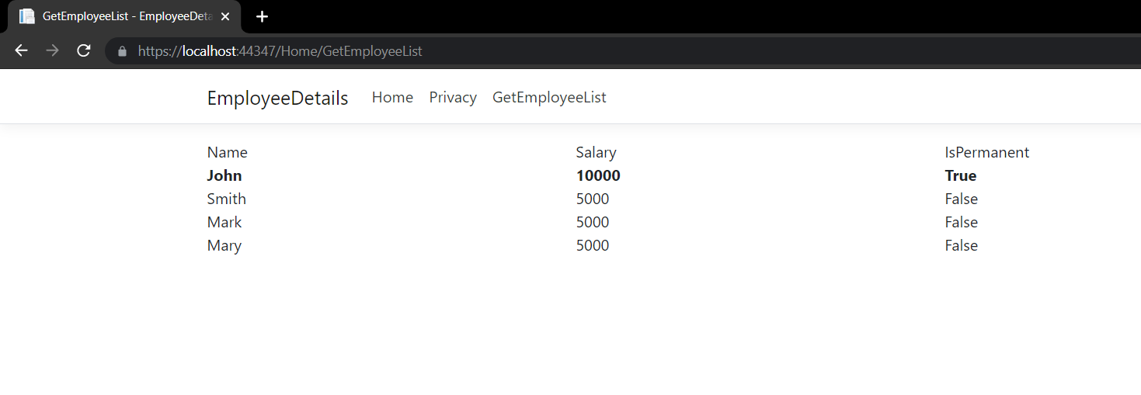

1. **Demonstrate partial view usage.**

**Employee.cs**

using System;

using System.Collections.Generic;

using System.Linq;

using System.Threading.Tasks;

namespace EmployeeDetails.Models

{

public class Employee

{

public int Id { get; set; }

public string Name { get; set; }

public decimal Salary { get; set; }

public bool IsPermanent { get; set; }

}

}

**HomeController.cs**

using EmployeeDetails.Models;

using Microsoft.AspNetCore.Mvc;

using Microsoft.Extensions.Logging;

using System;

using System.Collections.Generic;

using System.Diagnostics;

using System.Linq;

using System.Threading.Tasks;

namespace EmployeeDetails.Controllers

{

public class HomeController : Controller

{

private readonly ILogger<HomeController> _logger;

public HomeController(ILogger<HomeController> logger)

{

_logger = logger;

}

public IActionResult Index()

{

return View();

}

public IActionResult Privacy()

{

return View();

}

public IActionResult GetEmployeeList()

{

List<Employee> employeeList = new List<Employee>();

employeeList.Add(new Employee()

{

Id = 1,

Name = "John",

Salary = 10000,

IsPermanent = true

});

employeeList.Add(new Employee()

{

Id = 2,

Name = "Smith",

Salary = 5000,

IsPermanent = false

});

employeeList.Add(new Employee()

{

Id = 3,

Name = "Mark",

Salary = 5000,

IsPermanent = false

});

employeeList.Add(new Employee()

{

Id = 4,

Name = "Mary",

Salary = 5000,

IsPermanent = false

});

return View(employeeList);

}

[ResponseCache(Duration = 0, Location = ResponseCacheLocation.None, NoStore = true)]

public IActionResult Error()

{

return View(new ErrorViewModel { RequestId = Activity.Current?.Id ?? HttpContext.TraceIdentifier });

}

}

}

**GetEmployeeList.cshtml**

@*

For more information on enabling MVC for empty projects, visit https://go.microsoft.com/fwlink/?LinkID=397860

*@

@{

}

< partial name = "partialGetEmployeeList" />

**partialGetEmployeeList.cshtml**

@*

For more information on enabling MVC for empty projects, visit https://go.microsoft.com/fwlink/?LinkID=397860

*@

@model List<EmployeeDetails.Models.Employee>

@{

ViewData["Title"] = "GetEmployeeList";

< div class= "row" >

< span class= "col-md-4" > Name </ span >

< span class= "col-md-4" > Salary </ span >

< span class= "col-md-4" > IsPermanent </ span >

</ div >

}

@foreach(var employee in Model)

{

< div class= "row" >

@if(employee.IsPermanent.Equals(true))

{

< span class= "col-md-4" >< b > @employee.Name </ b ></ span >

< span class= "col-md-4" >< b > @employee.Salary </ b ></ span >

< span class= "col-md-4" >< b > @employee.IsPermanent </ b ></ span >

}

else

{

< span class= "col-md-4" > @employee.Name </ span >

< span class= "col-md-4" > @employee.Salary </ span >

< span class= "col-md-4" > @employee.IsPermanent </ span >

}

</ div >

}

**_Layout.cshtml**

< !DOCTYPE html >

< html lang = "en" >

< head >

< meta charset = "utf-8" />

< meta name = "viewport" content = "width=device-width, initial-scale=1.0" />

< title > @ViewData["Title"] - EmployeeDetails </ title >

< link rel = "stylesheet" href = "~/lib/bootstrap/dist/css/bootstrap.min.css" />

< link rel = "stylesheet" href = "~/css/site.css" />

</ head >

< body >

< header >

< nav class= "navbar navbar-expand-sm navbar-toggleable-sm navbar-light bg-white border-bottom box-shadow mb-3" >

< div class= "container" >

< a class= "navbar-brand" asp - area = "" asp - controller = "Home" asp - action = "Index" > EmployeeDetails </ a >

< button class= "navbar-toggler" type = "button" data - toggle = "collapse" data - target = ".navbar-collapse" aria - controls = "navbarSupportedContent"

aria - expanded = "false" aria - label = "Toggle navigation" >

< span class= "navbar-toggler-icon" ></ span >

</ button >

< div class= "navbar-collapse collapse d-sm-inline-flex flex-sm-row-reverse" >

< ul class= "navbar-nav flex-grow-1" >

< li class= "nav-item" >

< a class= "nav-link text-dark" asp - area = "" asp - controller = "Home" asp - action = "Index" > Home </ a >

</ li >

< li class= "nav-item" >

< a class= "nav-link text-dark" asp - area = "" asp - controller = "Home" asp - action = "Privacy" > Privacy </ a >

</ li >

< li class= "nav-item" >

< a class= "nav-link text-dark" asp - area = "" asp - controller = "Home" asp - action = "GetEmployeeList" > GetEmployeeList </ a >

</ li >

</ ul >

</ div >

</ div >

</ nav >

</ header >

< div class= "container" >

< main role = "main" class= "pb-3" >

@RenderBody()

</ main >

</ div >

< footer class= "border-top footer text-muted" >

< div class= "container" >

&copy; 2021 - EmployeeDetails - < a asp - area = "" asp - controller = "Home" asp - action = "Privacy" > Privacy </ a >

</ div >

</ footer >

< script src = "~/lib/jquery/dist/jquery.min.js" ></ script >

< script src = "~/lib/bootstrap/dist/js/bootstrap.bundle.min.js" ></ script >

< script src = "~/js/site.js" asp - append - version = "true" ></ script >

@RenderSection("Scripts", required: false)

</ body >

</ html >

**OUTPUT:**

